Case 17-AM,C-Taino-Cohoba Plate-Anthropomorphic Head-1200-1450

## 

Case No.: 18

Accession Number:

Formal Label:

**Display Description:**

LC Classification:

Date or Time Horizon:

Geographical Area:

Map:

GPS Coordinates:

Cultural Affiliation:

Medium:

**Dimensions**: 9" X 7" X 2".  
**Weight:** 7 LBS

Provenance: ORIGINALLY FROM A DOMINICAN REPUBLIC COLLECTION. Ex N. Chern has been an eBay member since Sep 08, 2007.

**Condition: Vesicular Basalt**

**Discussion:** THIS DENSE ROCK IS COVERED WITH APPROPRIATE DEPOSITS. APPROXIMATELY 1000-1500 AD. ARTIFACT IS WELL DETAILED.

**References:**

Price: US $30,000.00

Sold by [nchern](http://myworld.ebay.com/nchern) ( [1453](http://feedback.ebay.com/ws/eBayISAPI.dll?ViewFeedback&userid=nchern) )

### Delivery package 1 of 1

Estimated delivery Monday, Dec 21, 2015

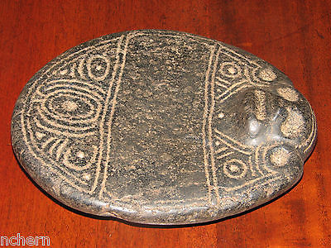

#### [TAINO PRE COLUMBIAN COHOBA TABLE. DENSE STONE.](http://www.ebay.com/itm/351598080828)

|  |  |
| --- | --- |
| Item price | $599.99 |
| Quantity | 1 |
| Item number | 351598080828 |
| Shipping service | USPS Priority Mail |

## Shipping address

Ralph J Coffman Jr

149 Atlantic Ave

Swampscott MA 01907-2427

United States

## Order total

|  |  |
| --- | --- |
| Subtotal | $979.53 |
| Shipping | $32.49 |

**Total**

$1,012.02